<Project Title>

<Project Title>

<Month and Year Submitted>

<Authors as First M. Last>

Insert project photo to replace this placeholder.

Disclaimer

The contents of this report reflect the views of the authors, who are responsible for the facts and the accuracy of the information presented herein. This document is disseminated in the interest of information exchange. The report is funded, partially or entirely, by a grant from the U.S. Department of Transportation’s University Transportation Centers Program. However, the U.S. Government assumes no liability for the contents or use thereof.

**TECHNICAL REPORT DOCUMENTATION PAGE**

|  |  |  |  |  |  |  |
| --- | --- | --- | --- | --- | --- | --- |
| 1. Report No. | 2. Government Accession No. | | | 3. Recipient’s Catalog No. | | |
| 4. Title and Subtitle  <Project Title> [select the field, hit F9, and delete this text] | | | | 5. Report Date  <Month and Year Submitted> [select the field, hit F9, and delete this text] | | |
| 6. Performing Organization Code | | |
| 7. Author(s) <Authors as First M. Last> | | | | 8. Performing Organization Report No.  <CARTEEH project #> | | |
| 9. Performing Organization Name and Address: CARTEEH UTC  <Institution Name(s) and Address> | | | | 10. Work Unit No. | | |
| 11. Contract or Grant No. 69A3551747128 | | |
| 12. Sponsoring Agency Name and Address  Office of the Secretary of Transportation (OST) U.S. Department of Transportation (USDOT) | | | | 13. Type of Report and Period Final  Insert project period of performance | | |
| 14. Sponsoring Agency Code | | |
| 15. Supplementary Notes  This project was funded by the Center for Advancing Research in Transportation Emissions, Energy, and Health University Transportation Center, a grant from the U.S. Department of Transportation – Office of the Assistant Secretary for Research and Technology, University Transportation Centers Program. (insert other funding sources if any) | | | | | | |
| 16. Abstract  <Abstract highlighting the major findings of the project. TRDP should not go over one page.> | | | | | | |
| 17. Key Words  <Key words separated by commas> | | | 18. Distribution Statement  No restrictions. This document is available to the public through the CARTEEH UTC website.  http://carteeh.org | | | |
| 19. Security Classif. (of this report)  Unclassified | | 20. Security Classif. (of this page)  Unclassified | | | 21. No. of Pages  11 | 22. Price  $0.00 |

**Form DOT F 1700.7 (8-72)** Reproduction of completed page authorized

Executive Summary

The executive summary should serve as a high-level, standalone project brief (up to two pages) that succinctly describes the problem, the work conducted, and outputs, outcomes, and impacts resulting from the study. Please include the following sections:

1. Problem statement—describe the motivation and need for the project, including a statement of the problem to be solved or the research needed.
2. Technical objectives—describe the technical objectives of the study, including the approach and methodology used to achieve the research goals.
3. Key findings—highlight the key study findings, including relevant outputs and outcomes.
4. Project impacts—describe the impacts of the study on:

* The effectiveness of the transportation system.
* The adoption of new practices.
* The body of scientific knowledge.
* Transportation workforce development.

Acknowledgments

(Optional) Acknowledge any other contributors and sources of project funding other than CARTEEH.

Table of Contents

List of Figures ii

List of Tables ii

Report Guidelines (FOR REFERENCE—Delete This Section) 2

Review and Publication Process 2

Figures 2

Tables 2

Sample Level 1 Heading 2

Sample Level 2 Heading 2

Sample Level 3 Heading 2

Background and Introduction 2

Problem 2

Approach 2

Methodology 2

Results 2

Conclusions and Recommendations 2

Research Outputs, Outcomes, and Impacts 2

Technology Transfer Outputs, Outcomes, and Impacts 2

Education Outputs, Outcomes, and Impacts 2

# List of Figures

Figure 1. Sample image with caption. (Use sentence case; end with a period.) 2

# List of Tables

Table 1. Sample Table Caption (Capitalize Each Word, and Do Not End with a Period) 2

# Report Guidelines (FOR REFERENCE—Delete This Section)

## Formatting and Content

Follow these guidelines in preparing your report:

* Use only the styles provided in this template if possible:
* Heading 1, Heading 2, Heading 3, and Heading 4.
* Body Text, List Bullet, List Bullet 2, and List Number.
* Figure and Figure Caption.
* Table Caption, Table Header, and Table Text.
* Organize the report into sections or chapters to give a complete description of the project, including data gathered, analyses performed, and results achieved. Use appendices as needed for supplementary materials.
* Heading names (Methods, Results, etc.) in this document are solely for demonstration purposes. Rename or rerrange section headings as necessary, but make sure to include a description of the following required elements:
* The research problem.
* Current literature and the state of the practice.
* The approach and methodology.
* Data collection, analysis, and results.
* Findings, conclusions, and recommendations.
* Research outputs, outcomes, and impacts.
* Technology transfer outputs, outcomes, and impacts.
* Education outputs, outcomes, and impacts.
* Cite your sources using a consistent format.

If you would like information on how to use templates, please visit <http://tti.tamu.edu/group/communications/word-template-instructions/>.

## Review and Publication Process

The principal investigator (PI) should submit the Project Closeout Checklist and draft Final Research Report within **60 days** after the project completion date. CARTEEH leadership will then review the report and determine whether additional edits are necessary prior to its approval. If edits are required, the report will be returned to the PI with comments on requested revisions.

Once revisions are completed, the final documents should be returned to CARTEEH for final approval. After notifying the PI of the final approval, CARTEEH administration will upload the research report to the CARTEEH website and various repositories, per the grant’s requirements.

## Figures

High-resolution images are preferred if possible. Use automatic cross references to mention each figure in the text (Figure 1).

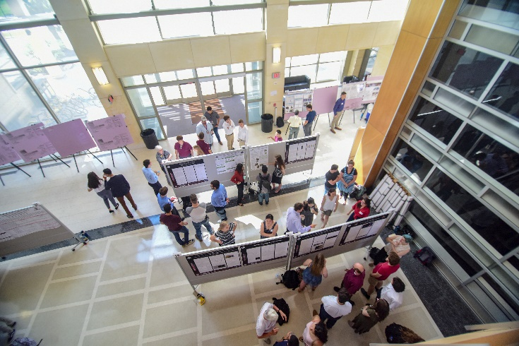

Figure 1. Sample image with caption. (Use sentence case; end with a period.)

## Tables

Use automatic cross references to mention each table in the text (Table 1). Tables should be created using Word’s formatting if possible.

Table 1. Sample Table Caption (Capitalize Each Word, and Do Not End with a Period)

|  |  |  |  |  |
| --- | --- | --- | --- | --- |
| Title 1 | Title 2 | Title 3 | Title 4 | Title 5 |
| The table should be centered on the page. | Headers for the columns should be in Table Header style and shaded 20 percent gray. | Units should be given in the header and not repeated in cells. | All table text should use the Table Text style and be centered. | Tables should not split across the page unless absolutely necessary. |
| Info 1 | Info 2 | Info 3 | Info 4 | Info 5 |

# Sample Level 1 Heading

## Sample Level 2 Heading

In order to use a subheading, you need to divide chunks of information. Therefore, you should have at least two subheadings.

Use **Body Text** style for paragraphs. Use a sentence to introduce bullets:

* Bullet. Use **List Bullet** style.
* Bullet.
* Bullet.
* Sub-bullet. **Use List Bullet 2** style.
* Sub-bullet.
* Sub-bullet.

### Sample Level 3 Heading

Use **Body Text** style. Use a sentence to introduce numbered lists:

1. List element. Use **List Number** style.
2. List element.
3. List element.

#### Sample Level 4 Heading

Use **Body Text** style. Try not to go beyond level 4 headings.

# Background and Introduction

Use **Body Text** style.

# Problem

Use **Body Text** style.

# Approach

Use **Body Text** style.

# Methodology

Use **Body Text** style.

### Study area and time period

Text here ….

### Census data

Text here ….

### Air pollution exposure data

Text here ….

#### NO2 exposure

#### PM2.5 exposure

#### PM10 exposure

### Asthma incidence rate data

Text here ….

#### National asthma incidence rate

#### State-specific asthma incidence rate

### Concentration response function

Test here ….

### Burden of disease methodology

Text here ….

### Counterfactual scenarios

Text here ….

### Sensitivity analysis

Test here ….

### Running the analysis

Test here ….

#### Software used

#### Spatial maps production

#### 500 cities lookup table

# Results

Use **Body Text** style.

# Conclusions and Recommendations

Use **Body Text** style.

# Outputs, Outcomes, and Impacts

**[Delete these section instructions]**

**Outputs**: new or improved processes, practices, technologies, software, training aids, or other tangible products resulting from this activity.

**Outcomes**: changes made to the transportation system, or its regulatory, legislative, or policy framework, resulting from research outputs.

**Impacts:** the effects of an outcome on the transportation system, or society in general, such as reduced fatalities, decreased operating costs, etc.

## Research Outputs, Outcomes, and Impacts

**[Delete these section instructions]**

Please provide a detailed description of all **research** outputs, outcomes, and impacts resulting from this study.

Examples include:

* Peer-reviewed publications.
* Presentations at conferences and technical meetings.
* Changes to policy or regulations, or decisions that were informed by research findings.

## Technology Transfer Outputs, Outcomes, and Impacts

**[Delete these section instructions]**

Please provide a detailed description of all technology transfer outputs, outcomes, and impacts resulting from this study.

Examples include:

* Data sets produced, including digital object identifier (doi).
* Code developed, including links to a repository.
* Software developed, including doi.
* Intellectual property generated, including subject inventions, patent applications, and issued patents.
* Strategic partnerships formed to inform decision-making or drive technology adoption, including public and private sectors.

## Education and Workforce Development Outputs, Outcomes, and Impacts

**[Delete these section instructions]**

Please provide a detailed description of all education and workforce development outputs, outcomes, and impacts resulting from this study.

Examples include:

* Students involved in the project.
* Outreach to students conducted at the K-12 and university level as part of the project.
* Training and educational materials developed, including curricula, lectures, and classroom exercises.
* Innovative educational and outreach methods deployed as a result of the project.